**Project Design Phase-I**

**Solution Architecture**

|  |  |
| --- | --- |
| Date | 17 October 2022 |
| Team ID | PNT2022TMID19760 |
| Project Name | SmartFarmer – IoT ENABLED SMART FARMING APPLICATION |
| Maximum Marks | 4 Marks |

**Solution Architecture:**

Solution architecture is a complex process – with many sub-processes – that bridges the gap between business problems and technology solutions. Its goals are to:

* Find the best tech solution to solve existing business problems.
* Describe the structure, characteristics, behavior, and other aspects of the software to project stakeholders.
* Define features, development phases, and solution requirements.
* Provide specifications according to which the solution is defined, managed, and delivered.

**Solution Architecture Diagram:**

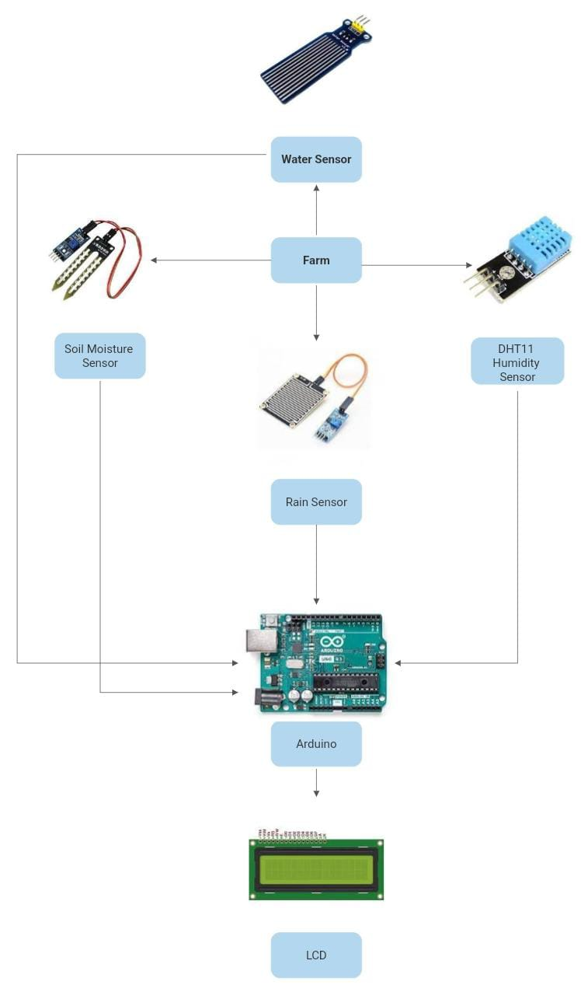

* Different sensors are used to measure the various soil characteristics (temperature, humidity, and soil moisture), and the results are saved in the IBM cloud.
* The data from sensors and weather data from weather API are processed using an Arduino UNO as a processing unit.
* The hardware, software, and APIs are connected using Node-red as a programming tool. The MQTT protocol is utilized for communication.
* A mobile application that was created utilizing the MIT app inventor gives the user access to all the collected data. Depending on the sensor results, the user might decide via an app whether to irrigate the crop or not. They are able to remotely control the motor switch by utilizing the app.